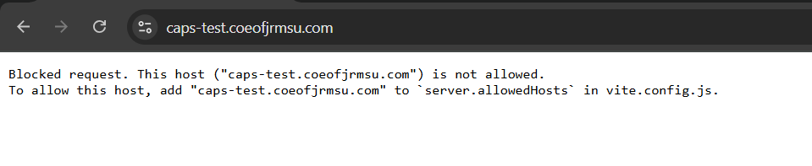

HOW TO FIX:
1. navigate to caps-frontend/vite.config.js
2. Update it from this:
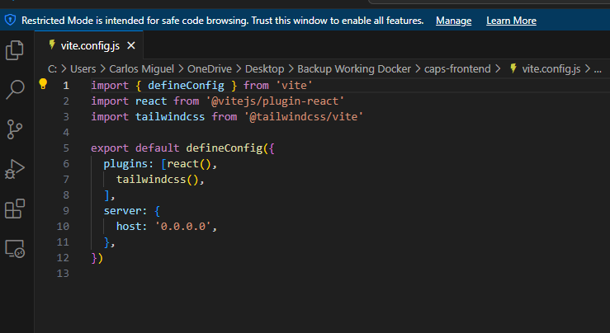
To:
